Financial Analysis of the Tootsie Roll Industries



Tootsie Roll Headquarter: 7401 South Cicero Avenue, Chicago, IL 60629
Tootsie Roll Phone Number: +1 (773) 838-3400

Name: Rupa Shrestha
Student ID: 4266261

Table of Contents

1. Company Overview 4
2. Financial Overview: 7
a. Sales and Income Record: 7
b. Expense Distribution: 7
c. Assets Distribution: 8
d. Capital Structure: 9

Table of figures
Figure 1: Tootsie Roll Organizational Chart. 4
Figure 2: Tootsie Roll headquarter. 5
Figure 3: Tootsie Roll Location. 6
Figure 4: Sales and income record graph. 7
Figure 5: Expense distribution 2023 pie-chart. 8
Figure 6: Assets distribution 2023 pie-chart. 9
Figure 7: Capital structure 2023 pie-chart. 10

Company Overview

Company Description:
Tootsie Roll Industries, Inc. is a well-known candy company that has been making and selling sweets for more than 100 years. They are famous for treats like Tootsie Rolls, Tootsie Pops, and Dubble Bubble gum. With over a century of experience in the candy industry, the company focuses exclusively on the production and sale of a wide variety of candy products.
Company History:
Leo Hirshfield established Tootsie Roll Industries in the late 19th century. It has been in the confectionery industry for over 100 years. With the introduction of new products like Tootsie Pop in the 1920s and 1930s, their popularity grew with time. By the 1960s, they expanded their business into Canada and Mexico, solidifying its position as one of the top candy manufacturers in North America. In the 2000s, they added new products and brands like Dubble Bubble and Charms and grew in the confectionery industry. Today, Tootsie Roll is one of the biggest candy makers in the U.S. and is well-known for its quality products and brand recognition.
Organization:
Tootsie Roll Industries operates as a single business segment focused solely on the confectionery industry. The company is structured with its headquarters in Chicago, they have factories in the U.S., Canada, and Mexico. They manage everything from one central place, making sure their candy is always high-quality and produced efficiently.
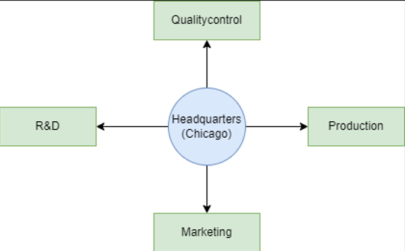
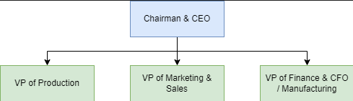
Figure 1: Tootsie Roll Organizational Chart.
Main products and services:
Tootsie Roll Industries offers a wide array of candy products, including Tootsie Roll, Tootsie Fruit Rolls, Frooties, Tootsie Pops, Tootsie Mini Pops, Child’s Play, Caramel Apple Pops, Charms, Blow-Pop, Charms Mini Pops, Cella’s, Dots, Junior Mints, Charleston Chew, Sugar Daddy, Sugar Babies, Andes, Fluffy Stuff, Dubble Bubble, Razzles, Cry Baby, Nik-L-Nip, And Tutsi Pop (Mexico).
Geographic area of operations:
- Primary Markets: United States, Canada, Mexico
- Retailers: Wholesale distributors of candy, food and groceries to supermarkets, dollar stores, chain grocers, drug chains, discount chains, cooperative grocery associations, mass merchandisers, warehouse and membership club stores, vending machine operators, ecommerce merchants, the U.S. military and fund-raising charitable organizations.
- Major Customers: Wal-Mart, Dollar Tree, McLane Company.
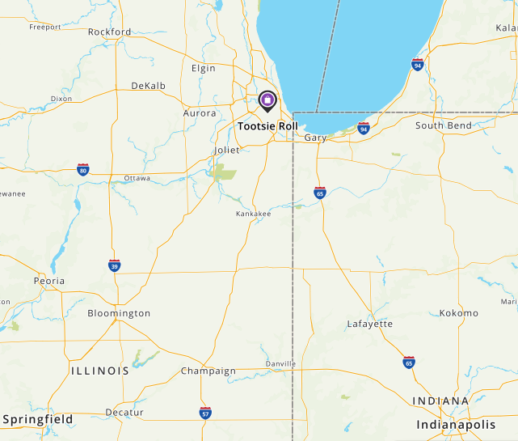
Figure 2: Tootsie Roll headquarter.

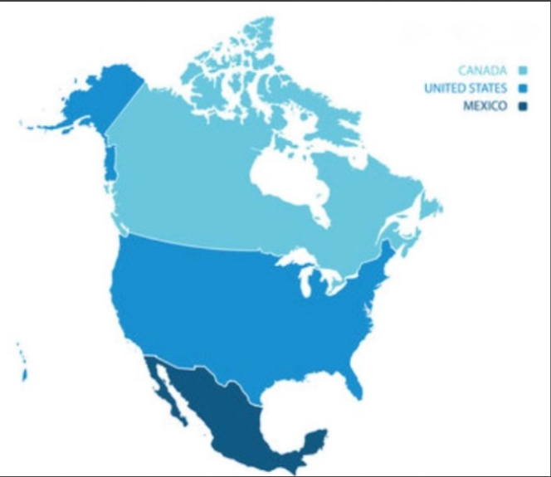
Figure 3: Tootsie Roll Location.
Recent developments:
The company has orders worth about $7 million same as December 31, 2023. To cover growing expenses for ingredients and packaging, they’re going to increase their prices. Some recent developments include:
Price Increases: Tootsie Roll is increasing its price on products to manage increasing costs for manufacturing, ingredients and packaging.
Product Innovations: Tootsie Roll continues to introduce new products and flavors to keep up with consumer preferences and trends.
Supply Chain Management: The company is enhancing its supply chain to ensure smooth and efficient delivery of raw materials and finished products, meeting growing market demand.
Digital Initiatives: Tootsie Roll has been investing in digital marketing with new marketing strategies and e-commerce to increase customer engagement.
Sustainability Initiatives: The company is investing in eco-friendly packaging and optimizing its production processes to reduce environmental impact.

2. Financial Overview:

a. Sales and Income Record:

Sales and Income Record 2020-2023
Year | Sales | Net Income | Sales Growth | Net Income Growth
2020 | $471,063 | $58,995
2021 | $570,776 | $65,326 | 21.2% | 10.7%
2022 | $686,970 | $75,937 | 20.4% | 16.2%
2023 | $769,365 | $91,912 | 12.0% | 21.0%
 | Avg: |  | 18% | 16%

Figure 4: Sales and income record graph.
Comment: Tootsie Roll net income have risen steadily in the last four years, averaging 16% growth per year in sales and 18% growth in sales. From the graph, we can see that in the up years net income and sales both have increased, which indicates gains in efficiency and effective cost management. Overall, the sales and income graph show the company has good finances with strong revenue and profit growth.

b. Expense Distribution:

Expense Distribution: Year-end FY 2023
Cost of Goods Sold & Royalty Cost | $512,525 | 78%
SG & A Expenses | $115,012 | 18%
Interest Expense | $337 | 0%
Income Tax | $28,008 | 4%
TOTAL | $655,882 | 100%

Tax Rate
income tax | $28,008
before-tax income | $119,894
rate | 23%

Figure 5: Expense distribution 2023 pie-chart.

Comment: More than 75% percent of Tootsie Roll expenses in 2023 consisted of cost of goods sold and royalty cost which means significant production costs. It may be high because of its manufacturing cost and brand license fee or intellectual property. Selling, general, and administrative expenses make up less than twenty percent, which seems reasonable for Tootsie Roll. Income tax makes up about 4% and interest makes up 0% which means it is effectively managing its financing costs.

c. Assets Distribution:

Assets Distribution: Year-end FY 2023
Cash | $76,290 | 17%
Accounts Receivable | $55,568 | 12%
Inventory | $94,921 | 21%
Net Plant, and Equipment | $222,978 | 50%
TOTAL | $449,757 | 100%

Figure 6: Assets distribution 2023 pie-chart.

Comments: Nearly fifty percent of Tootsie Roll expenses in 2023 consisted of net plant and equipment which means a good amount has been invested in manufacturing and production facilities. Inventories are 21%, which means they have enough products available to meet customer demands. Accounts receivable is 12%, which means the money the company is expecting to collect from customers. It shows Tootsie healthy credit practices. Tootsie has 17% of cash is hand to run day-to-day operation and other expenses.

d. Capital Structure:

Capital Structure: Year-end FY 2023
Accounts Payable | $15,816 | 2%
Short-Term Debt | $1,088 | 0%
Other Current Liabilities | $10,044 | 1%
Long-Term Debt | $0 | 0%
Owner's Equity | $823,107 | 97%
TOTAL | $850,055 | 100%

Figure 7: Capital structure 2023 pie-chart.
Comment: Over ninety-five percent of equity is occupied by the owner, which shows a strong equity base and financial health. Tootsie accounts payable are less than 5%, which shows the company manages its payables efficiently. Other current liabilities are 1%, which shows minor short-term obligations. Minimal short-term debt indicates low reliance on short-term borrowing. No long-term debt means the company operates without long terms burrowing.

